**Pairs Trading Project Report**

**Abstract:**

This project involves pairs trading, a market-neutral trading strategy that matches a long position with a short position in a pair of highly correlated instruments. Here, we analyze the pair of stocks: HINDPETRO.NS and LICHSGFIN.NS.

**Key Metrics:**

* Correlation: 0.6346
* -Cointegration Test p-value: 0.4261
* Performance Metrics:

Mean Squared Error (MSE): 0.000201

R-squared: 0.9174

* Drawdown:

Maximum Market Drawdown: -59.25%

Maximum Strategy Drawdown: -28.42%

* Returns:

Final Market Return: -27.62%

Final Strategy Return: 101.19%

**Loading Dataset**

The dataset was loaded using the `yfinance` library, which provides historical market data from Yahoo Finance.

**Correlation Analysis**

A correlation matrix was plotted to identify pairs of stocks with high correlation. The pair selected for this study, HINDPETRO.NS and LICHSGFIN.NS, exhibited a correlation of 0.6346, indicating a moderate positive relationship.

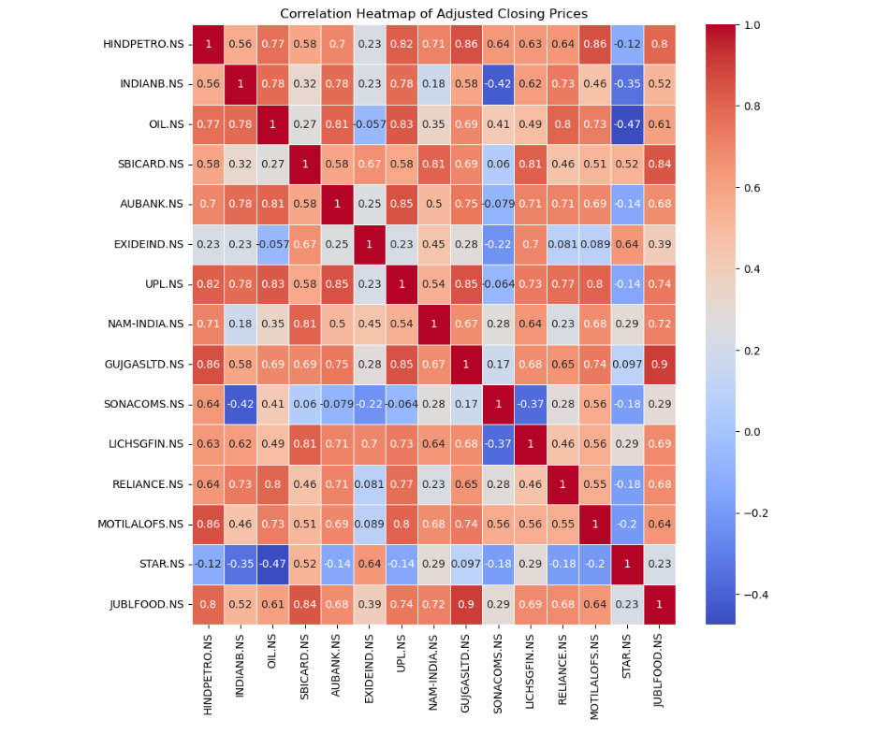

**Choosing HINDPETRO.NS and LICHSGFIN.NS:**

After choosing HINDPETRO.NS and LICHSGFIN.NS which has a correlation value of 0.63. I loaded their historic data.

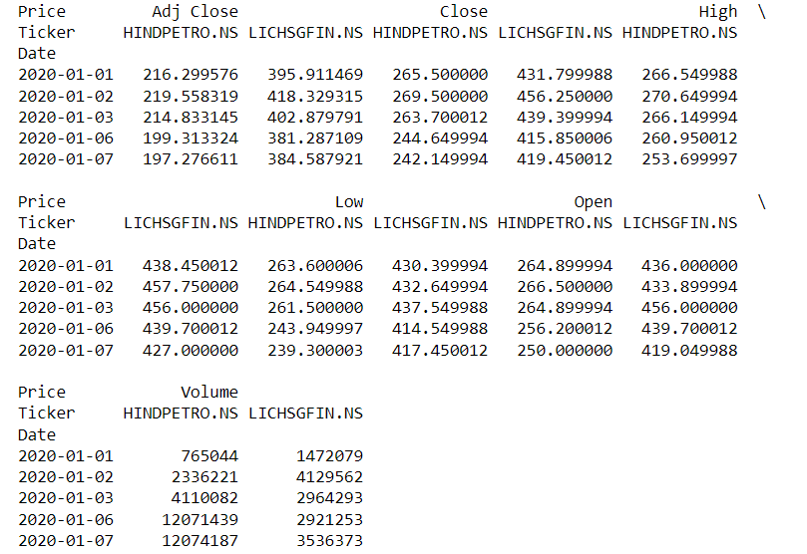

**Price Ratio Analysis**

The price ratio between the two stocks was plotted to visualize the spread. This helps in identifying the mean-reverting behavior essential for pairs trading.

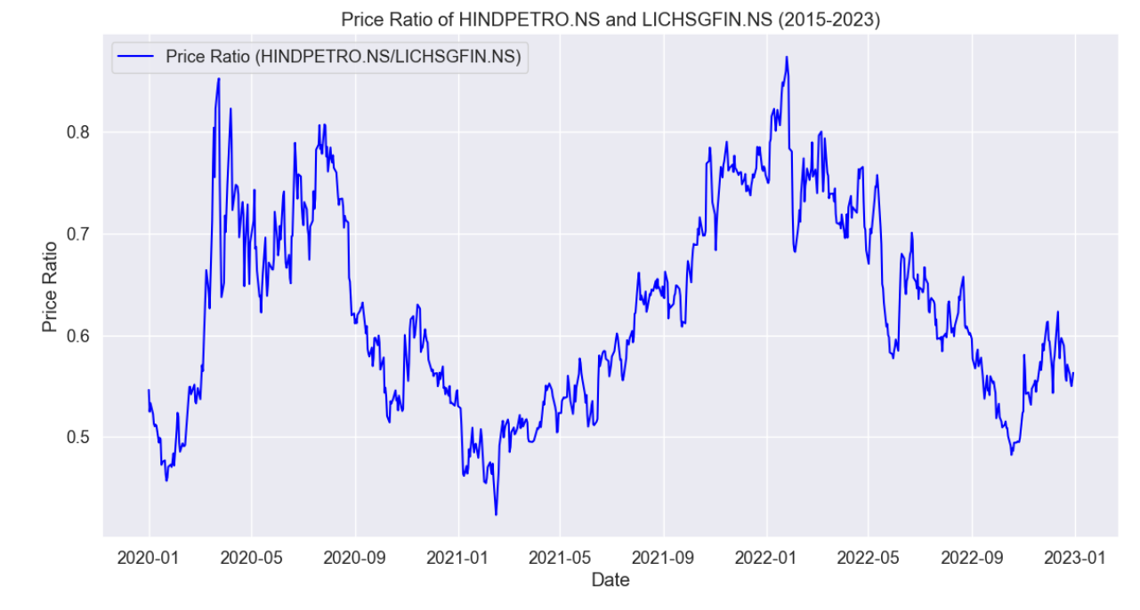

**Cointegration Test**

The Engle-Granger cointegration test was performed to ensure that the selected pairs are cointegrated. The p-value obtained was 0.4261, suggesting that the null hypothesis of no cointegration cannot be rejected.

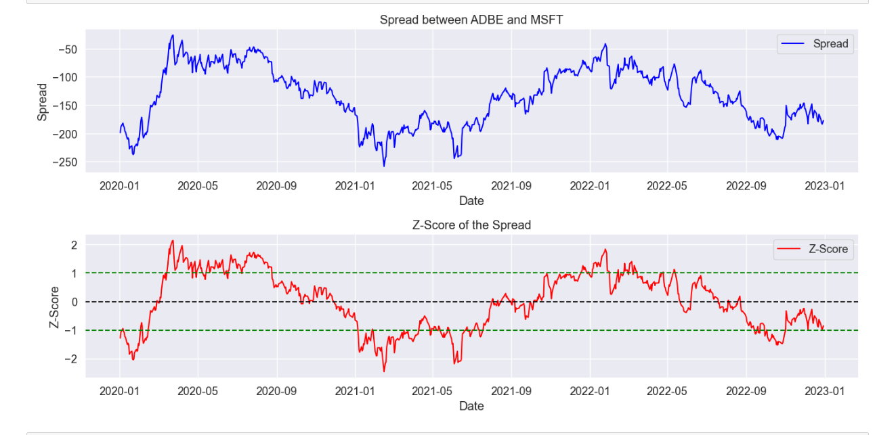

**Performance Metrics**

Using **Linear Rigression model** I have trained the model on historical data and predict y value on test set.

This is the performance metrics:

**Mean Squared Error (MSE):** The MSE of 0.000201 indicates the average squared difference between the observed and predicted values.

**R-squared:** An R-squared value of 0.9174 indicates that 91.74% of the variability in the dependent variable is explained by the model.

**Z-score with Buying and Selling signal:**

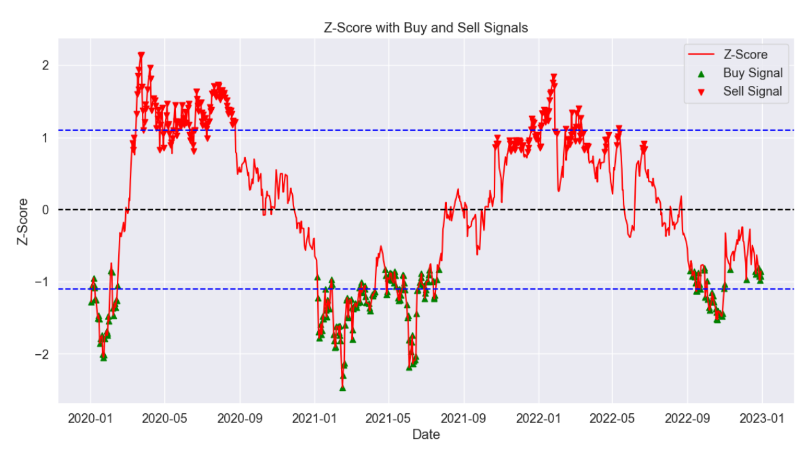

**Drawdown Analysis**

**Maximum Market Drawdown:** The maximum observed loss in market value was -59.25%.

**Maximum Strategy Drawdown:** The strategy experienced a maximum drawdown of -28.42%, indicating the largest drop from peak to trough before a new peak is achieved.

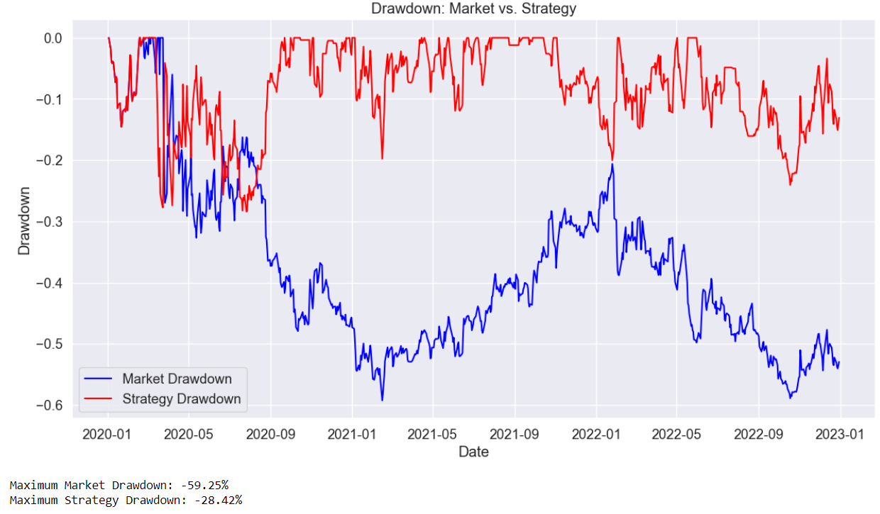

**Return Analysis**

**Final Market Return:** The market returned -27.62% over the analysis period.

**Final Strategy Return**: The strategy returned 101.19%, demonstrating the effectiveness of the pairs trading strategy.

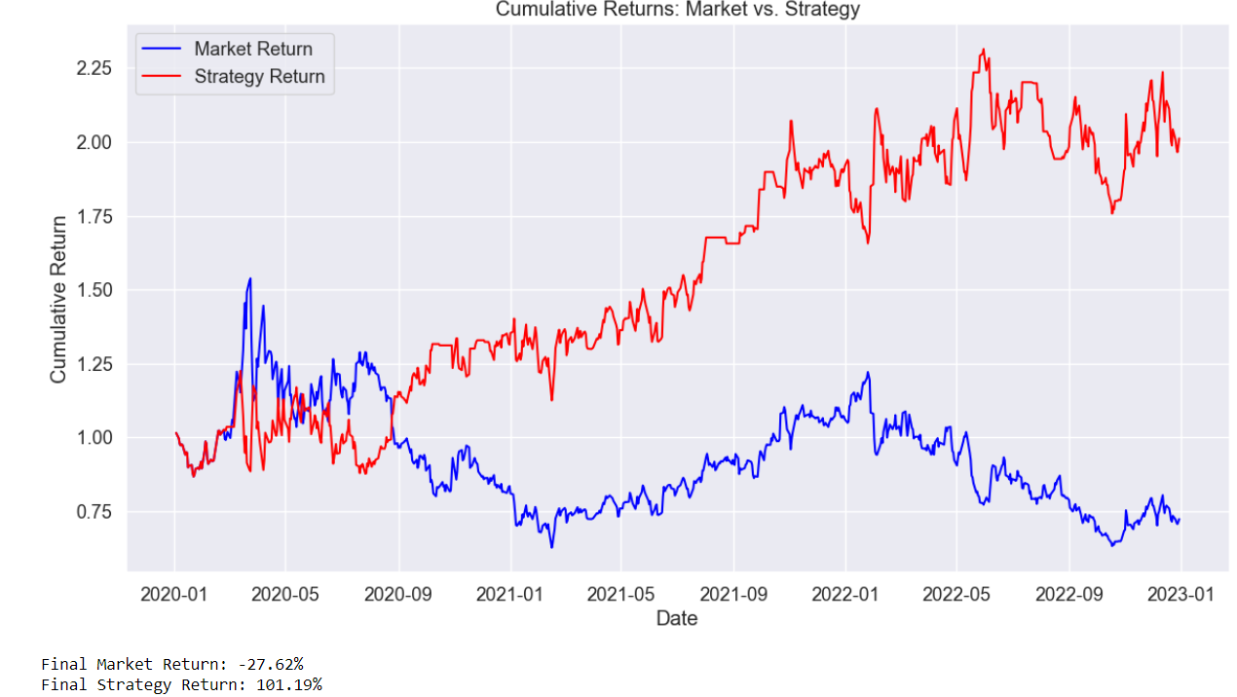

**Conclusion**

The pairs trading strategy implemented on HINDPETRO.NS and LICHSGFIN.NS showed a significant positive return despite the market downturn, proving the strategy's robustness in a declining market. The high R-squared value and moderate correlation, coupled with the substantial strategy return, underscore the potential for pairs trading as a viable trading strategy.